Linear Equations and Slope Name______________________________
1. A line has a slope of 3/5 and a y-intercept of 4. Write the equation of the line.
2. Is this an uphill or downhill line: y=-2/3x+5.
3. Where does the line y=3x-7 cross the y-axis?
4. What is the slope of the line x=-3?
5. Find the x and y intercepts of the line 2x - 4y = 16

6. Write -2x + 3y = 10 in slope intercept form.

Write the equation of each line below. Then tell the slope of each.
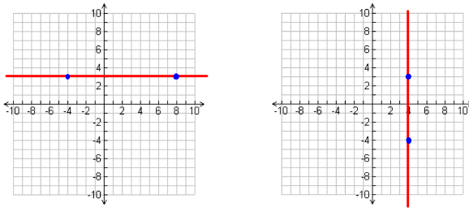
7. Equation: 9. Equation:
8. Slope: 10. Slope:

11. Graph y=-2/3x + 3 12. Find the slope of the line below:
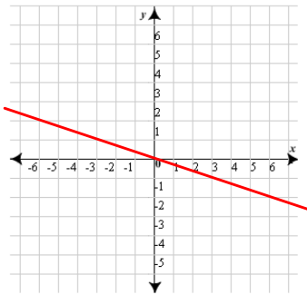
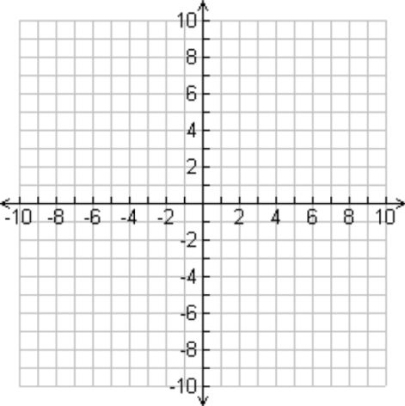

13. Write the equation of the line below: 14. Graph the equation y=3
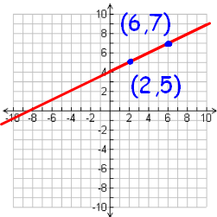
15. Graph the equation y=3x 16. Find the slope of the line below:
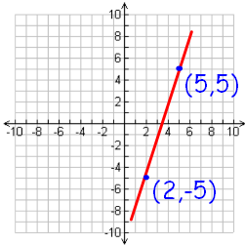
17. Graph 2x + 3y = 12 18. Graph y = 2x + 5
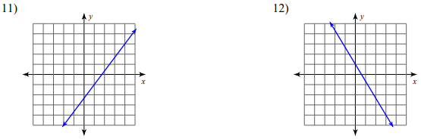
Find the slope of each:

